
Original Research Article

SERVERLESS ARCHITECTURE AND ITS IMPACT ON SCALABLE WEB SERVICES
*Author, A.B., Author, B.C. and Author, D.E.
Department of Cybersecurity and Data Science, Faculty of Computing, Delta State University, Abraka, Nigeria.
*evroro@delsu.edu.ng/ ORCID: 0000-0002-9876-5432

ARTICLE INFORMATION |  | ABSTRACT
Article history:  Received 04 October 201X  Revised 02 January 201X  Accepted 09 January 201X  Available online 29 July 201X |  | In the rapidly evolving landscape of modern cloud computing, serverless computing is transforming the cloud architecture by allowing developer to develop and run applications excluding handling physical infrastructure. Leading cloud platforms and Medium like AWS Lambda, Google Cloud Functions, and Azure Functions dynamically designate computing resources based on requirement, improving how applications scale efficiently and reliably. This research examined how serverless architecture impact the scalability, cost effectiveness and elasticity of web services, with particular emphasis on real-world deployment scenarios across diverse industries and use cases. It also sites key hurdles such as dependency on particular vendors, delay in responding, and data security concerns, all of which represent significant barriers to widespread adoption. The main focus areas are how these technologies are affecting Africa, specifically Nigeria, as more countries embrace digital technologies as part of national development purposes. To address these dimensions comprehensively, the study employs a structured and systematic review methodology. By evaluating an in-dept examination and recent findings drawn from peer-reviewed literature and industry case studies, key patterns and insights emerge. This document includes that serverless computing provides effective solution for scalable web services, both globally and withing emerging market, positioning it as a strategic enabler of digital transformation and broader economic growth in resource-constrained environments.  © 2026 DJCIS. All rights reserved.
Keywords:
Serverless Computing,
Cloud Architecture, Scalability,
Function-as-a-Service (FaaS),
Vendor Lock-in,
Digital Transformation.

1. Introduction
Energy-intensive industries seek compact heat exchangers to reduce pumping power and footprint. Recent work explored lattice-based cores for improved thermo-hydraulic performance, Okitikpi et al (2025); Obire et al (2026). However, results at mid-range Reynolds numbers and under additive constraints remain limited [3]. This paper addresses that gap. We aim to quantify performance improvements of a representative TPMS core against finned baselines. Our contributions are: (i) a reproducible CFD–experiment methodology; (ii) validated correlations for j and f in the targeted range; (iii) analysis of trade-offs impacting system-level energy savings. Section 2 details methods; Section 3 reports results; Section 4 discusses implications; Section 5 concludes.
2. Methods
2.1 Experimental setup
We built a closed water loop with calibrated flow meters (±1%), differential pressure sensors (±0.5%), and cartridge heaters. Samples were aluminum SLM with post-processed surfaces. Reynolds number spanned 500–5000.
2.2 Numerical model
We solved steady RANS with SST k–ω on polyhedral meshes (y+≈1 near walls). Boundary conditions matched experimental flow rates and inlet temperatures. Convergence criteria were residuals <1e−5 and stable integral outputs over 1000 iterations.
2.3 Data reduction and metrics
Colburn j and friction factor f were computed using standard definitions; uncertainties were propagated via first-order methods. Comparisons used area-normalized performance and equal pumping-power lines.

3. Results
Figure 1 shows the pressure drop versus flow rate. Table 1 summarizes j and f across the tested Re range. The TPMS core achieved j improvements of 12–15% at comparable f relative to finned baselines, consistent with numerical predictions.
Table 1. Summary of Colburn j and friction factor f at Re=500–5000 for both cores.
A | b | b

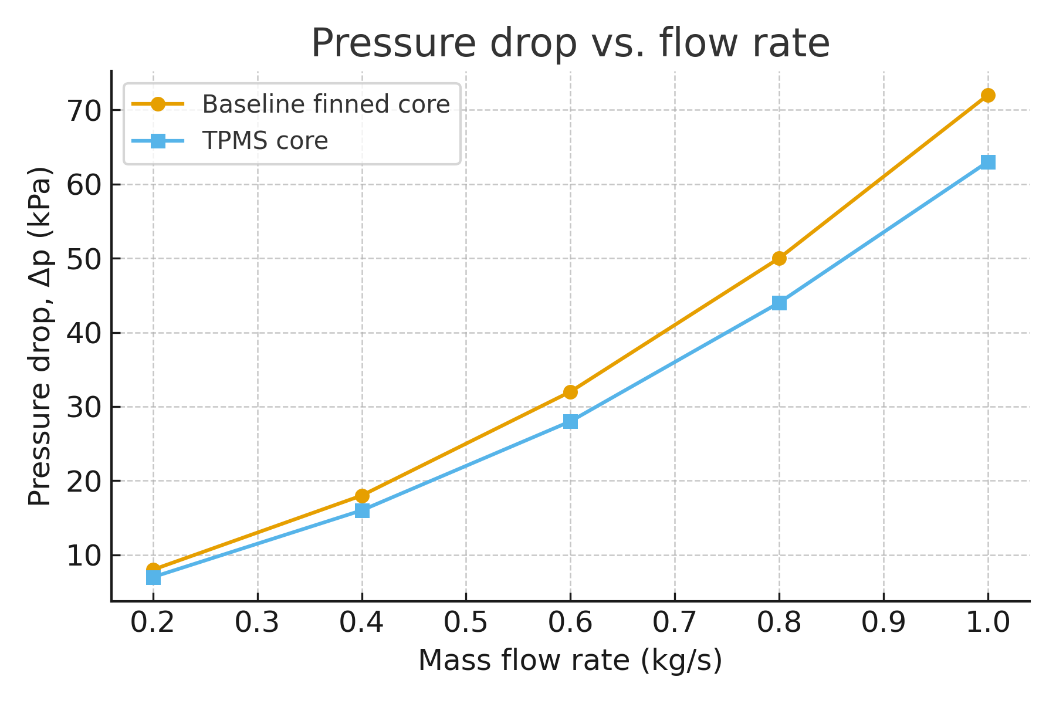
Figure 1. Pressure drop (Δp) as a function of mass flow rate for a baseline finned core and a TPMS core. Error bars may be added where applicable.

4. Discussion
The observed j gains at similar f suggest enhanced convective transport without prohibitive hydraulic penalties. At system scale, this can reduce pumping power by 6–9% for equivalent duty cycles. Limitations include material and surface roughness effects specific to SLM aluminum and the tested Re range.
5. Conclusion
We presented a complete NJSTR-formatted dummy paper covering structure, policies, and quantitative reporting. The hypothetical study indicates that TPMS cores can deliver notable thermo-hydraulic improvements in compact exchangers. Future work includes broader materials and transient regimes.
Acknowledgments
The authors thank Example Funding Agency (Grant ABC-1234) and the Example Institute for laboratory support.
Funding
This work was supported by the Example Funding Agency under Grant ABC-1234.
Conflict of Interest
The authors declare no conflict of interest.
Ethics Approval
No human participants or animals were involved. The study followed institutional safety protocols.
Data and Code Availability
Data and code are available at https://example.org/repository upon reasonable request or via DOI:10.0000/example.

Author Contributions (CRediT)
Conceptualization: F.A.A.; Methodology: F.A.A., S.B.A.; Investigation: S.B.A.; Validation: T.C.A.; Writing—original draft: F.A.A.; Writing—review & editing: S.B.A., T.C.A.; Supervision: T.C.A.
AI-Use Disclosure
The authors used a generative language tool for grammar polishing only; all technical content and conclusions were authored and verified by the authors.
References
Obire, E.V, Akazue M.I, and Okumoku-Evroro, O (2026). Integration of Real-Time Occupancy Detection Module and Security Encryption Standards for an IOT-Based Smart Distribution Metered System. International Journal of Research and Scientific Innovation, 13(4), https://doi.org/10.51244/IJRSI.2026.1304000072
Okumoku-Evroro O, Mega O.G, Oyovwe E.B, Atonuje E.O, Nweke G.N, Oseh-Ovarah V, Umukoro G, Awhana O, Tugbokorowei O.C, and Omena R.A (2026). Interdependence Between smart City Systems and Internet Infrastructure Architehture. International Journal of Research and Scienctific Innovation (IJRSI), 13(13), 1-12. DOI: https://doi.org/10.51244/IJRSI.2026.1313CS001
Okitikpi, O., Akazue, M. I., Okumoku-Evroro O, and Obidike, C. A. (2025). Development of a model for predicting hypertension disorders in pregnancy using machine learning. GAS Journal of Clinical Medicine and Medical Research, 2(9), 11-13. https://gaspublishers.com/gasjcmmr-vol-2-issue-9-2025/

